Software Requirements Specification (SRS)

Smart Course Hub

(Web Engineering Case Study)

1. Introduction

1.1 Purpose
This SRS describes the requirements for SmartCourseHub, a web-based university course & enrollment management system built using Spring Boot, Spring Data JPA, MySQL, and ReactJS.
It is intended for:
- Developers (students)
- Course instructor
- Testers

1.2 Scope
SmartCourseHub provides:
- Course catalog management
- Course section offerings
- Student enrollment & timetable
- Attendance recording
- Assignment & grade management
- Academic progress / transcript views
Front-end: ReactJS
Back-end: Spring Boot REST APIs
Database: MySQL

1.3 Definitions
- Section: A specific offering of a course in a semester (with time, room, instructor).
- Enrollment: A mapping between student and course section.
- Assignment: A graded assessment (quiz, assignment, project, exam).

2. Overall Description

2.1 Product Perspective
SmartCourseHub is a new web application, not replacing an existing one (in case study). It has:
- Presentation Layer: ReactJS SPA
- Business Layer: Spring Boot REST services
- Data Layer: Spring Data JPA + MySQL

2.2 User Classes & Roles
- Admin
  - Manage users, courses, programs, sections
- Instructor
  - Manage attendance, assignments, grades
- Student
  - Manage enrollments, view schedule, marks, transcript

2.3 Operating Environment
- Server: Java 17+, Spring Boot 3.x
- DB: MySQL 8+
- Client: Modern browser (Chrome/Edge/Firefox)

3. Functional Requirements (FR)

FR-1 User Management
- System shall allow admins to create, update, and deactivate users.
- Users shall be assigned roles: ADMIN, INSTRUCTOR, STUDENT.
- System shall provide login functionality with email + password.
- System shall issue a JWT token on successful authentication.

FR-2 Course Management (Admin)
- Admin shall create a course with attributes: code, title, description, creditHours.
- Admin shall update or delete courses not yet used by any section.
- Admin shall create Sections with course, instructor, day/time, room, capacity.

FR-3 Enrollment (Student)
- Student shall view the list of available sections.
- Student shall enroll in a section if:
  - They are authenticated
  - Enrollment period is open
  - Seats are available
- System shall prevent duplicate enrollment in same section.
- Student shall view and drop their enrollments (subject to drop rules).

FR-4 Attendance (Instructor)
- Instructor shall view list of enrolled students for a section.
- Instructor shall mark attendance for a given date as PRESENT or ABSENT.
- Student shall be able to view own attendance per course.

FR-5 Assignments & Grades
- Instructor shall create assignments for a section with:
  - title, description, totalMarks, deadline.
- Students shall view assignments of enrolled sections.
- Instructor shall record/modify marks per student per assignment.
- Student shall view assignment marks and course total.

FR-6 Academic Progress
- Student shall view a summary of courses, grades, and GPA.
- System shall calculate per-course grade and overall GPA (simplified formula acceptable).

4. Non-Functional Requirements (NFR)
- Performance:
  - Typical API response < 300ms under normal load.
- Scalability:
  - System shall support at least 5,000 concurrent users.
- Security:
  - All API calls (except login/register) require JWT.
  - Passwords stored as salted hashes (e.g., BCrypt).
- Usability:
  - Responsive UI (Bootstrap/Tailwind) to run on mobile/laptop.
- Maintainability:
  - Modular packages (controller, service, repository, dto, entity).
- Reliability:
  - Transactional updates for enrollment, grades, attendance.

5. External Interface Requirements
- REST API (JSON over HTTP)
- React Front-End (Axios calls to /api/**)

6. Constraints
- Must use: Spring Boot, Spring Data, MySQL, ReactJS
- DB design must support relational integrity with foreign keys.

UML Diagrams

2.1 Use Case Diagram (High Level)

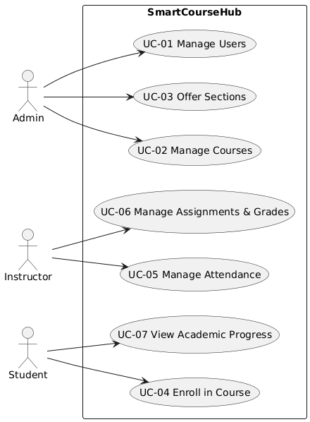

2.2 Class Diagram (Core Domain)
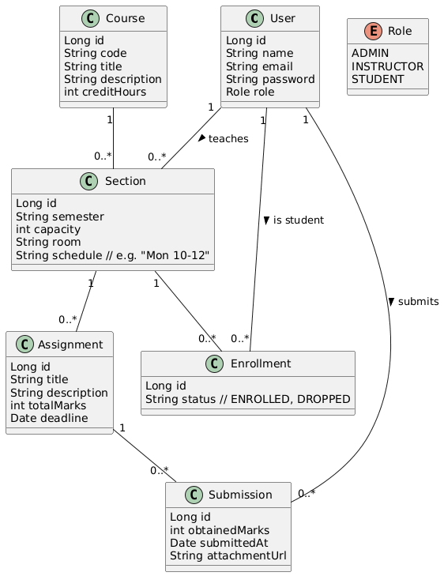

2.3 Sequence Diagram – UC-04 Enroll in Course
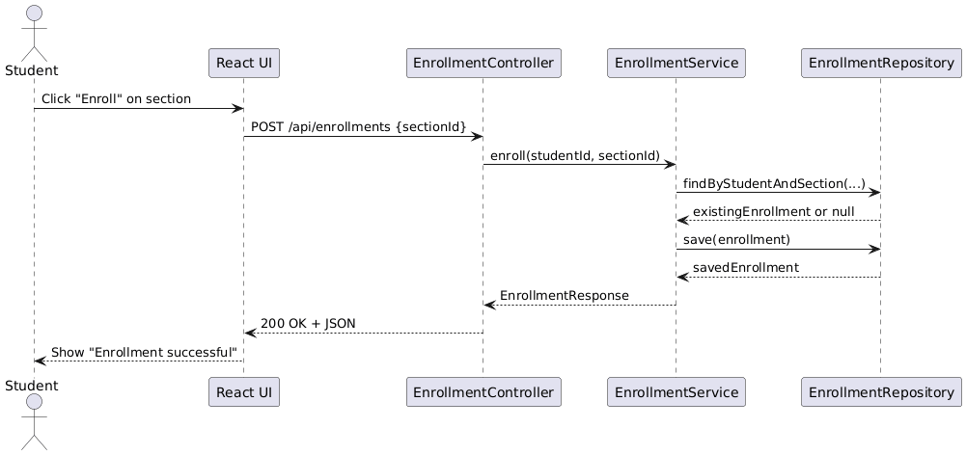

2.4 Activity Diagram – Manage Assignment & Grades (Instructor)
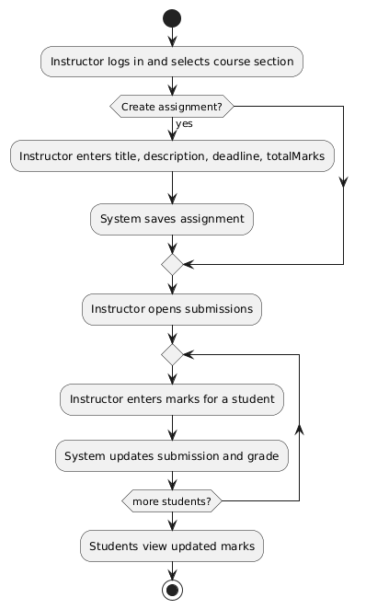

4.2 Package Structure
com.smartcoursehub
├─ SmartCourseHubApplication.java
├─ config
│ ├─ SecurityConfig.java
│ └─ JwtFilter.java
├─ auth
│ ├─ AuthController.java
│ ├─ AuthService.java
│ └─ JwtUtil.java
├─ user
│ ├─ User.java
│ ├─ Role.java
│ ├─ UserRepository.java
│ └─ UserService.java
├─ course
│ ├─ Course.java
│ ├─ CourseRepository.java
│ ├─ CourseService.java
│ └─ CourseController.java
├─ section
│ ├─ Section.java
│ ├─ SectionRepository.java
│ └─ SectionController.java
├─ enrollment
│ ├─ Enrollment.java
│ ├─ EnrollmentRepository.java
│ └─ EnrollmentController.java
└─ assignment
├─ Assignment.java
├─ Submission.java
├─ AssignmentRepository.java
├─ SubmissionRepository.java
└─ AssignmentController.java

ReactJS Skeleton (with Bootstrap ready)
Folder Structure
smartcoursehub-frontend/
├─ src/
│ ├─ api/
│ │ └─ axiosClient.js
│ ├─ components/
│ │ ├─ Navbar.js
│ │ └─ ProtectedRoute.js
│ ├─ pages/
│ │ ├─ LoginPage.js
│ │ ├─ AdminDashboard.js
│ │ ├─ CourseListPage.js
│ │ ├─ StudentDashboard.js
│ │ └─ InstructorDashboard.js
│ ├─ App.js
│ └─ index.js
└─ package.json

package.json (dependencies)

{
"name": "smartcoursehub-frontend",
"version": "0.1.0",
"private": true,
"dependencies": {
"axios": "^1.7.0",
"bootstrap": "^5.3.0",
"react": "^18.3.0",
"react-bootstrap": "^2.10.0",
"react-dom": "^18.3.0",
"react-router-dom": "^6.22.0"
}
}

Full Dress Use Cases

main use cases in fully dressed format:
- UC-01 – Manage Users (Admin)
- UC-02 – Manage Courses (Admin)
- UC-03 – Offer Course Sections (Admin)
- UC-04 – Enroll in Course (Student)
- UC-05 – Manage Attendance (Instructor)
- UC-06 – Manage Assignments & Grades (Instructor)
- UC-07 – View Academic Progress (Student)

UC-01 – Manage Users
Use Case ID: UC-01
Use Case Name: Manage Users
Primary Actor: Admin
Level: User-goal
Scope: SmartCourseHub Web Application

1. Brief Description
This use case describes how an Admin creates, updates, and deactivates user accounts (students, instructors, admins) in the system.

2. Stakeholders and Interests
- Admin: Wants to register and control access for all users.
- Instructors/Students: Need valid accounts to access system features.
- IT/Institution: Needs controlled, secure access and proper role assignments.

3. Preconditions
- Admin is authenticated and authorized.
- System is online and connected to the database.

4. Postconditions
- Success: User account is created/updated/deactivated in the database with appropriate role.
- Failure: No changes are made to user records.

5. Main Success Scenario (Basic Flow)
- Admin logs into the system.
- Admin navigates to “User Management”.
- System displays a list of existing users.
- Admin clicks “Create New User”.
- System displays a form for user details: name, email, role, initial password.
- Admin fills in details and submits.
- System validates the input (unique email, required fields).
- System saves the new user in the database with selected role.
- System confirms that the user has been created and shows updated list.

6. Alternate / Extension Flows
- 6A – Invalid Input:
  - 7a. If required fields are missing or invalid format, system displays validation errors.
  - 7b. Admin corrects details and resubmits (return to step 7).
- 6B – Duplicate Email:
  - 7c. If email already exists, system shows “Email already registered”.
  - 7d. Admin enters a different email and resubmits (back to step 7).
- 6C – Update User:
  - 4a. Instead of creating, Admin clicks “Edit” next to a user.
  - 4b. System shows an editable form.
  - 4c. Admin updates allowed fields and submits.
  - 4d. System validates and saves changes (continue at step 8).
- 6D – Deactivate User:
  - 4e. Admin clicks “Deactivate” on a user.
  - 4f. System asks for confirmation.
  - 4g. On confirmation, system marks user as inactive (e.g., enabled = false).

7. Special Requirements
- Role-based authorization (only Admin can access user management).
- Password must be stored hashed.
- UI must clearly show active vs inactive users.

8. Frequency of Use
- At semester start/end, and when new users join/leave.

UC-02 – Manage Courses
Use Case ID: UC-02
Use Case Name: Manage Courses
Primary Actor: Admin
Level: User-goal
Scope: SmartCourseHub

1. Brief Description
Admin maintains the course catalog by creating, editing, and removing courses.

2. Stakeholders & Interests
- Admin: Needs up-to-date course catalog.
- Instructors/Students: Depend on correct course definitions.

3. Preconditions
- Admin is logged in with proper role.

4. Postconditions
- Success: Course is stored/updated/removed properly.
- Failure: No unintended changes to existing course data.

5. Main Success Scenario
- Admin opens “Course Management”.
- System shows list of existing courses.
- Admin clicks “Add Course”.
- System shows form: code, title, description, creditHours.
- Admin enters required details and submits.
- System validates course code uniqueness and required fields.
- System saves the new course in the database.
- System displays confirmation and updated course list.

6. Alternate / Extension Flows
- 6A – Edit Course:
  - 3a. Admin clicks “Edit” on a course.
  - 3b. System shows existing values for editing.
  - 3c. Admin updates data and submits.
  - 3d. System validates and updates record.
- 6B – Delete Course (Not used in any section):
  - 3e. Admin clicks “Delete” next to a course.
  - 3f. System checks if course is linked to any section.
  - 3g. If no sections use it, system deletes and confirms.
- 6C – Cannot Delete (In Use):
  - 3h. If course is referenced by one or more sections, system shows message “Course is in use and cannot be deleted”.

7. Special Requirements
- Course code must be unique.
- Course delete operation must be protected to avoid data inconsistencies.

8. Frequency of Use
- Low to moderate (start of each academic year/semester).

UC-03 – Offer Course Sections
Use Case ID: UC-03
Use Case Name: Offer Course Sections
Primary Actor: Admin
Scope: SmartCourseHub

1. Brief Description
Admin creates course sections for specific semesters and assigns an instructor, room, time, and capacity.

2. Preconditions
- Courses exist in the catalog.
- Instructors exist as users with role INSTRUCTOR.

3. Postconditions
- Success: New section is defined and available for student enrollment.
- Failure: No inconsistent or partial section data is stored.

4. Main Success Scenario
- Admin selects “Section Management”.
- System shows list of existing sections.
- Admin clicks “Create Section”.
- System displays a form with fields:
  - Select Course
  - Select Instructor
  - Semester (e.g., “Spring 2026”)
  - Capacity
  - Room
  - Schedule (e.g., “Mon 10–12”)
- Admin fills the fields and submits.
- System validates references (course/instructor exist) and required fields.
- System saves the section in DB.
- Section appears in the list and is available in the Student Enrollment view.

5. Alternate / Extension Flows
- 5A – Invalid Capacity:
  - 6a. If capacity <= 0, system shows error.
  - 6b. Admin corrects and resubmits (back to step 6).
- 5B – Instructor Not Available (business rule):
  - 6c. System checks schedule conflicts (optional advanced rule).
  - 6d. If instructor has overlapping section, warn admin:
    - Admin may cancel or override if allowed by policy.

6. Special Requirements
- Section must reference valid Course and Instructor.
- Optional: Prevent time clashes for the same instructor.

7. Frequency of Use
- Mainly at the beginning of each semester.

UC-04 – Enroll in Course
Use Case ID: UC-04
Use Case Name: Enroll in Course
Primary Actor: Student
Level: User-goal
Scope: SmartCourseHub

1. Brief Description
Student enrolls in a course section and gets it added to their timetable and academic records.

2. Stakeholders & Interests
- Student: Wants smooth enrollment and visibility of schedule.
- Instructor: Needs accurate list of enrolled students.
- Institution: Needs capacity control and correct enrollments.

3. Preconditions
- Student is authenticated.
- Enrollment period is open.
- Relevant sections exist.

4. Postconditions
- Success: Enrollment record (studentId, sectionId, status = ENROLLED) is created.
- Failure: No changes, and student receives an error/explanation.

5. Main Success Scenario
- Student logs into the system.
- Student navigates to “Course Catalog / Available Sections”.
- System shows list of sections with course code, title, instructor, schedule, capacity, and seats left.
- Student selects a section and clicks “Enroll”.
- System checks:
  - Student not already enrolled in this section.
  - Seats are available (enrolled count < capacity).
- System creates an enrollment record with status ENROLLED.
- System updates number of occupied seats.
- System confirms that enrollment is successful.
- Student can see this section listed under “My Courses / My Timetable”.

6. Alternate / Extension Flows
- 6A – Section Full:
  - 5a. If capacity reached, system shows message:
    - “Section full. Please select a different section.”
  - 5b. No enrollment record is created.
- 6B – Already Enrolled:
  - 5c. If enrollment already exists, system shows:
    - “You are already enrolled in this section.”
  - 5d. No duplicate record.
- 6C – Drop Enrollment (Variation):
  - 4a. Student goes to “My Courses”.
  - 4b. Student clicks “Drop” next to a section.
  - 4c. System checks if drop is allowed (within drop deadline).
  - 4d. System updates enrollment status to DROPPED and frees up seat.

7. Special Requirements
- Operations must be transactional – no race conditions in seat counting.
- Proper error messages should guide the student.

8. Frequency of Use
- High at the beginning of semester; occasional later.

UC-05 – Manage Attendance
Use Case ID: UC-05
Use Case Name: Manage Attendance
Primary Actor: Instructor
Scope: SmartCourseHub

1. Brief Description
Instructor marks student attendance for each session and can review or update it.

2. Preconditions
- Instructor is logged in.
- Instructor is assigned to at least one section.
- Students are enrolled in the selected section.

3. Postconditions
- Success: Attendance record is stored/updated for selected date.
- Failure: No invalid or partial attendance is saved.

4. Main Success Scenario
- Instructor logs in and navigates to “My Sections”.
- Instructor selects a section.
- Instructor chooses “Attendance” for a given date.
- System fetches list of enrolled students for that section.
- System displays a list with each student and a control (checkbox/dropdown) to mark present/absent.
- Instructor marks each student as PRESENT or ABSENT.
- Instructor submits the attendance form.
- System validates that date and section are valid and saves attendance for each student.
- System shows confirmation and indicates attendance saved for that date.

5. Alternate / Extension Flows
- 5A – Update Attendance:
  - 3a. Instructor selects a past date for which attendance exists.
  - 3b. System pre-fills the current status.
  - 3c. Instructor modifies any entries and resubmits (continue from step 8).
- 5B – No Enrolled Students:
  - 4a. If no students enrolled, system displays:
    - “No enrolled students for this section.”
  - 4b. Attendance submission is disabled.

6. Special Requirements
- Attendance date should not be in the far future (basic validation).
- Students should be able to view their own attendance summary.

7. Frequency of Use
- Once per section per class meeting.

UC-06 – Manage Assignments & Grades
Use Case ID: UC-06
Use Case Name: Manage Assignments & Grades
Primary Actor: Instructor
Scope: SmartCourseHub

1. Brief Description
Instructor creates assignments for a section and records grades for student submissions.

2. Preconditions
- Instructor is logged in.
- Instructor is assigned to at least one section.

3. Postconditions
- Success: Assignments and grades are stored and visible to students.
- Failure: System does not save incomplete or inconsistent data.

4. Main Success Scenario
- Instructor opens “My Sections” and selects a section.
- Instructor navigates to “Assignments”.
- System displays list of existing assignments for that section.
- Instructor clicks “Create Assignment”.
- System displays form with fields: title, description, totalMarks, deadline.
- Instructor enters data and submits.
- System validates fields (totalMarks > 0, deadline >= today).
- System saves the new assignment in the DB and updates the list.
Grading Flow:
- Instructor clicks on an assignment to view student submissions or enrollment list.
- System shows each student and fields for entering obtainedMarks.
- Instructor enters marks and submits.
- System validates marks (0 ≤ obtainedMarks ≤ totalMarks) and saves.
- Students can see their marks in their “My Grades / My Courses” view.

5. Alternate / Extension Flows
- 5A – Edit Assignment:
  - 4a. Instructor clicks “Edit” on an assignment.
  - 4b. System loads existing data.
  - 4c. Instructor updates and saves; system persists changes.
- 5B – Late Submission (optional business rule):
  - 10a. If system tracks submission time and it is after deadline, system may flag record as LATE or restrict grading, depending on policy.
- 5C – Invalid Marks:
  - 12a. If marks are out of range, system rejects input and shows error.
  - 12b. Instructor corrects and resubmits.

6. Special Requirements
- Grades should be visible only to respective student and authorized roles.
- Once final exam period is over, grades may be locked from editing (business rule).

7. Frequency of Use
- Several times per semester per section.

UC-07 – View Academic Progress
Use Case ID: UC-07
Use Case Name: View Academic Progress
Primary Actor: Student
Scope: SmartCourseHub

1. Brief Description
Student views a summary of enrolled courses, marks, grades, and computed GPA.

2. Preconditions
- Student is logged in.
- Student has at least one enrollment with grades, or system should handle empty state gracefully.

3. Postconditions
- Success: Progress report (per course, per semester) is displayed.
- Failure: System informs student if no data is available.

4. Main Success Scenario
- Student logs in and navigates to “My Grades / Academic Progress”.
- System retrieves student’s enrollments, assignments and marks.
- System computes per-course totals and final grade (based on predefined formula).
- System computes GPA (simple or weighted).
- System displays:
  - List of courses with grades
  - GPA (overall and/or semester-wise)
  - Optional graph (e.g., React chart component)
- Student reviews their academic progress.

5. Alternate / Extension Flows
- 5A – No Data Available:
  - 2a. If no enrollments or grades exist, system shows:
    - “No academic records available yet.”
  - 2b. Student sees an empty state message instead of error.
- 5B – Filter By Semester:
  - 1a. Student selects a semester filter (e.g., Spring 2026).
  - 1b. System filters and displays results for that semester only.

6. Special Requirements
- Calculation logic (how GPA and grades are derived) must be consistent and documented.
- Data must be read-only for students.

7. Frequency of Use
- Moderate to high; especially after exams or assignment grading.

